enquiries refer
Brigid Pearse
in reply please quote
23/54163

1 August 2023
Mr Jeremy Gray
Director – Northern Region
NSW Department of Planning and Environment
(Via Portal)
Attention: Ms Sandra Bush
Dear Ms Bush

Re: Request for Gateway Alteration PP- 2022- 4253 – Amendments to Ballina LEP 2012

(Council ref: BSCPP 22/011)

Reference is made to the above planning proposal and the Gateway Determination dated 23 December 2022.

The previous Gateway Alteration (GA-2023-15) to the Gateway Determination specifies a time frame for completing the LEP being on or before 30 August 2023. It is advised that council is unable to meet this time frame having regard to the following factor:

- Due to a misinterpretation of a Gateway Determination condition regarding SUGA No 10 Ross Lane / The Coast Road, proposed mapping for this SUGA is now inconsistent with the North Coast Regional Plan growth mapping.

Whilst reviewing the final draft mapping for PP-2022-4253, Department of Planning and Environment staff have advised of a mapping anomaly in the exhibited maps in relation to SUGA No 10, Ross Lane and The Coast Road, Lennox Head.

Prior to the Gateway Determination, Council proposed an extension to SUGA No 10 to the West and the removal of land to the south of the SUGA and to the east of The Coast Road as shown in Figure 1 (below).

Interpretation of the Gateway Determination conditions resulted in the extension to the West being removed. It also resulted in the land to the south of the SUGA and to the east of The Coast Road remaining included within the SUGA due to a misinterpretation of the Gateway conditions.

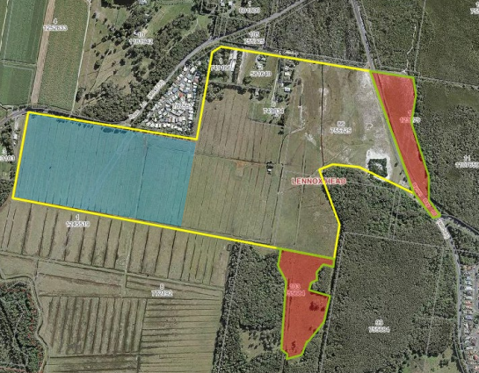

Figure 1. SUGA No 10 (bounded by yellow line) as adopted by Council at 10 October 2022 Extraordinary Council meeting. The red shade indicates areas to be removed from, and blue shade indicates area to be added to the existing BLEP 2012 SUGA Map.

A timeline outlining the background behind the changes to the mapping of SUGA No 10 is presented as follows:

- At the 26 May 2022 Ordinary meeting, Council resolved to publicly exhibit the draft Strategic Urban Growth Area Review report.

- The Strategic Urban Growth Area Review report was exhibited from 6 June to 6 July 2022. The area bounded by the yellow line in Figure 1 shows the area proposed to be included in SUGA No 10 as a result of the review.

- Two submissions were received in relation to the proposed SUGA No 10 ( as shown in Figure 1), one in support of the provision of employment lands in the area, the other citing concerns regarding environmental and cultural heritage impacts of any future development of this SUGA. No objections from the landowners contained within proposed SUGA No 10 were received as part of the SUGA review exhibition.

- The proposed SUGA No 10 (as shown in Figure 1) was reviewed by the Community Reference Group for the Lennox Head Strategic Plan, no issues were raised in relation to the proposed exclusion of land to the South of the SUGA and land to the East of The Coast Road.

- A SUGA Review Report was presented to Council on 10 October 2022 with a recommendation to add land proposed for future open space to the west of the existing SUGA, and remove land to the South of the SUGA and to the East of The Coast Road from SUGA Area 10 (See Figure 1), as proposed in the exhibited SUGA Review report. Council adopted this recommendation at the meeting.

- The SUGA Review Report, as amended by Council’s resolutions of 10 October 2022, was provided to DPE in October 2022 to help inform the draft North Coast Regional Plan 2041. In a letter to Council dated 4 November 2022, DPE approved the adopted SUGAs Review and subsequently included the updated SUGAs into the North Coast Regional Plan 2041, except for SUGA No 28 Russellton Industrial Estate, Alstonville, and the extension to SUGA No 10 Ross Lane/The Coast Road, Lennox Head (shaded blue in Figure 1).

- A planning proposal was prepared, based on Council’s 10 October 2022 resolution and forwarded to DPE for a Gateway Determination in mid December 2022.

- A Gateway Determination was received on 23 December 2022 and included a condition to remove the proposed Russellton Industrial Estate, Alstonville and expanded Ross Lane/The Coast Road, Lennox Head sites, consistent with the Department’s conditional approval of the SUGA Review on 4 November 2022 which identified further strategic justification and planning work was required to support the inclusion of these sites.

- Interpretation of this condition, when the mapping was prepared for the planning proposal, was that Council was to remove all proposed changes to SUGA No 10 Ross Lane/ The Coast Road. Hence the planning proposal was placed on public exhibition from 18 January to 10 February 2023 showing no changes to the existing SUGA at Ross Lan/The Coast Road, Lennox Head.

- No submissions regarding SUGA No 10 Ross Lane/ The Coast Road were received during public exhibition of the planning proposal.

- At the May 2023 Council meeting Council reviewed the public submissions and resolved to finalise and implement the amendment.

To resolve the misinterpretation, a resolution of Council is required. This cannot be achieved within the current timeframe.

Having regard to the above, council seeks a 4 week extension to complete the LEP with a completion date by 30 September 2023 being requested.

The project timeline below represents council’s best estimate of the likely completion time of the planning proposal.

Plan Making Step | Estimated Completion (Before)
Gateway Determination | 23 December 2022
Government Agency Consultation | February 2023
Public Exhibition Period | 18 January to 10 February 2023
Public Hearing | N/A
Submissions Assessment | March – April 2023
LPMA Assessment of Planning Proposal and Exhibition Outcomes | May 2023
LPMA Decision to Make the LEP Amendment | May 2023
Resolution of Council to rectify mapping error | August 2023
Forwarding of LEP Amendment to DPE for Notification | September 2023

If you have any enquiries in regard to this matter, please contact Brigid Pearse on 02 66810571 or via email Brigid.pearse@ballina.nsw.gov.au , please note my work days are Tuesdays and Wednesdays.

Yours faithfully

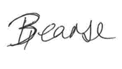

Brigid Pearse

Strategic Planner

Planning and Environmental Health Division

